Adder & Subtractors
Full Adder:
A full adder is a combinational logic circuit that adds three input bits (A, B, and a carry input, Cin) and generates two outputs: a sum (S) and a carry out (Cout).
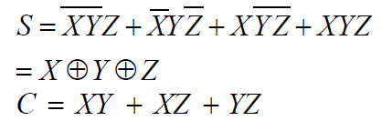
The truth table for a full adder is as follows:
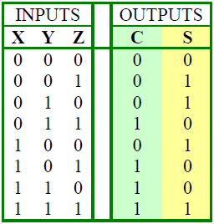
Figure 1. Full Adder Truth Table
4-bit Adder
A 4-bit adder is a fundamental digital circuit that performs addition on four pairs of binary digits, producing a sum and a carry output. It is commonly used in microprocessors, arithmetic logic units (ALUs), and various other digital systems where addition operations are required. The primary components of a 4-bit adder are full adder circuits, which are combined to create a multi-bit adder.
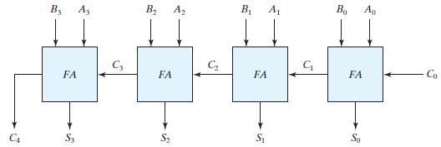
Figure 2. Logical Diagram of 4-bit Adder
Introduction
Subtractor circuits take two binary numbers as input and subtract one binary number input from the other binary number input. Similar to adders, it gives out two outputs, difference and borrow (carry-in the case of Adder). There are two types of subtractors.
- Half Subtractor
- Full Subtractor
1) Half Subtractor
The half-subtractor is a combinational circuit which is used to perform subtraction of two bits. It has two inputs, A (minuend) and B (subtrahend) and two outputs Difference and Borrow. The logic symbol and truth table are shown below.
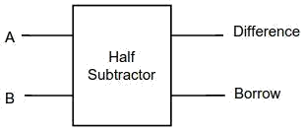
Figure-1:Logic Symbol of Half subtractor
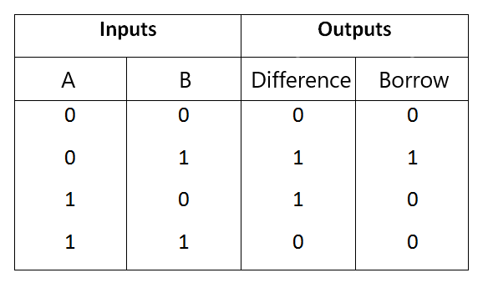
Figure-2:Truth Table of Half subtractor

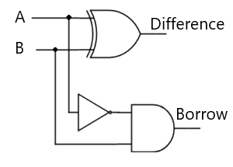
Figure-3:Circuit Diagram of Half subtractor

From the above truth table we can find the boolean expression.
Difference = A ⊕ B
Borrow = A' B
From the equation we can draw the half-subtractor circuit as shown in the figure 3.
2) Full Subtractor
A full subtractor is a combinational circuit that performs subtraction involving three bits, namely A (minuend), B (subtrahend), and Bin (borrow-in) . It accepts three inputs: A (minuend), B (subtrahend) and a Bin (borrow bit) and it produces two outputs: D (difference) and Bout (borrow out). The logic symbol and truth table are shown below.
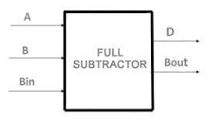
Figure-4:Logic Symbol of Full subtractor
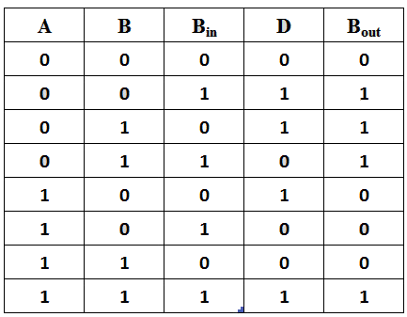
Figure-5:Truth Table of Full subtractor

From the above truth table we can find the boolean expression.
D = A ⊕ B ⊕ Bin
Bout = A' Bin + A' B + B Bin
From the equation we can draw the Full-subtractor circuit as shown in the figure 6.
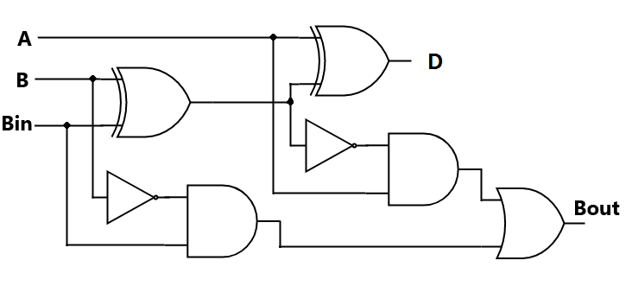
Figure-6:Circuit Diagram of Full subtractor

